Objective:

* Config NGINX L7 Load Balancer using single VM and deploy 2 services names with api.poridhi.io and fr.poridhi.io

Steps:

1. Create VPC

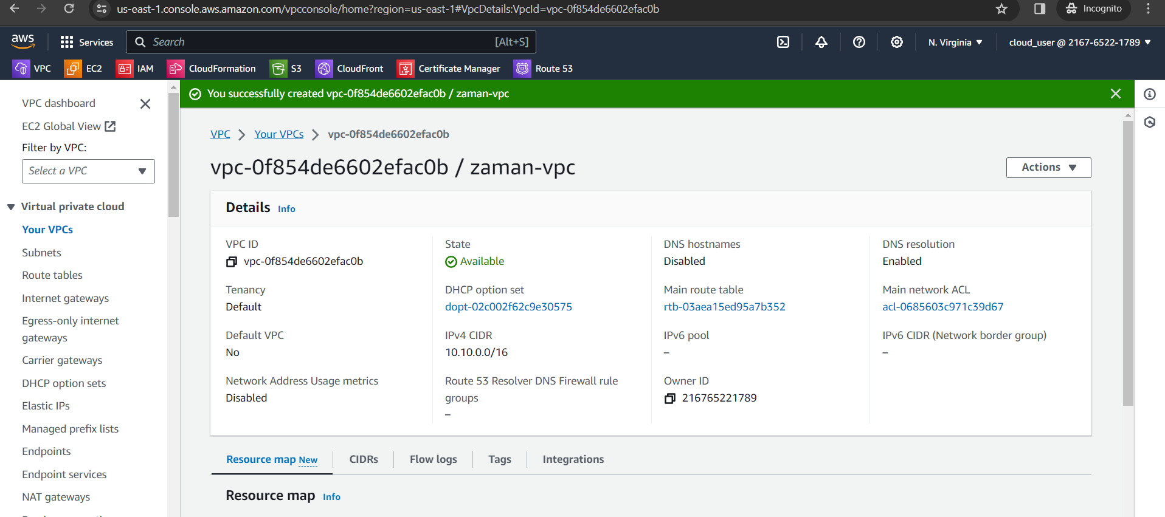

1. Create Subnet

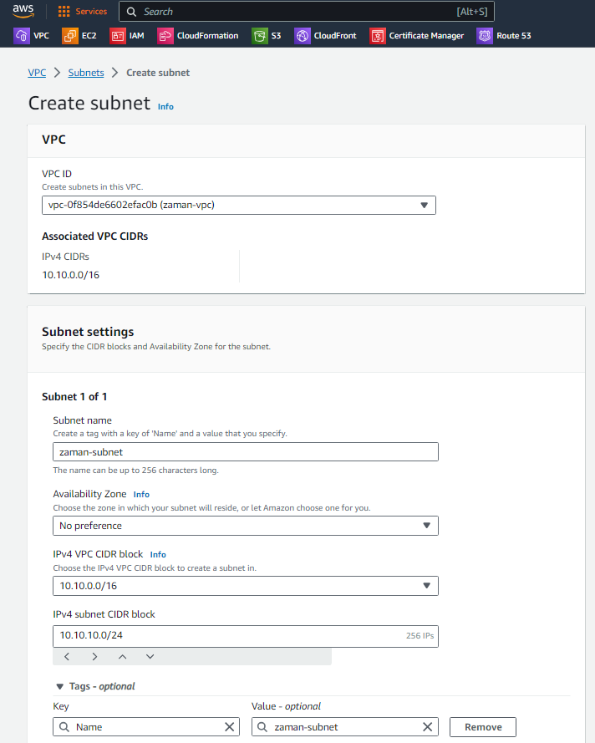

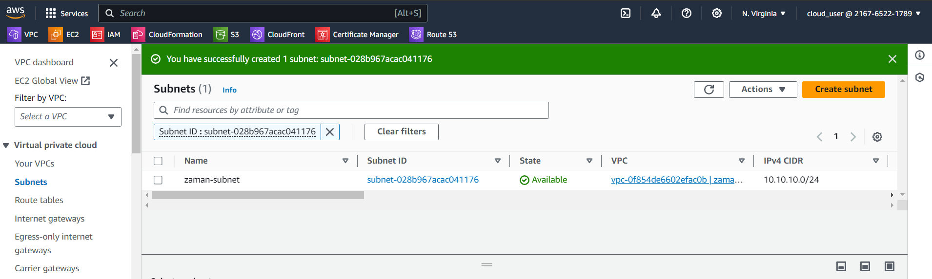

1. Create Internet Gateway and attach to the VPC

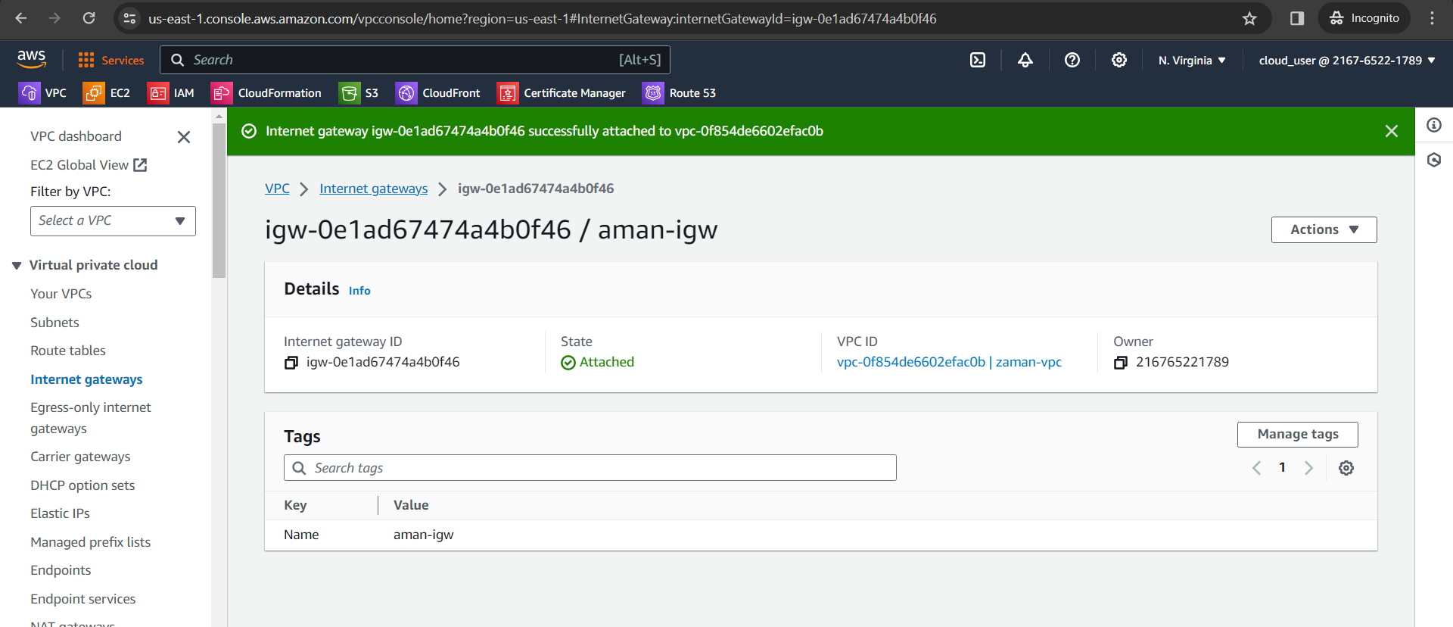

1. Add route 0.0.0.0

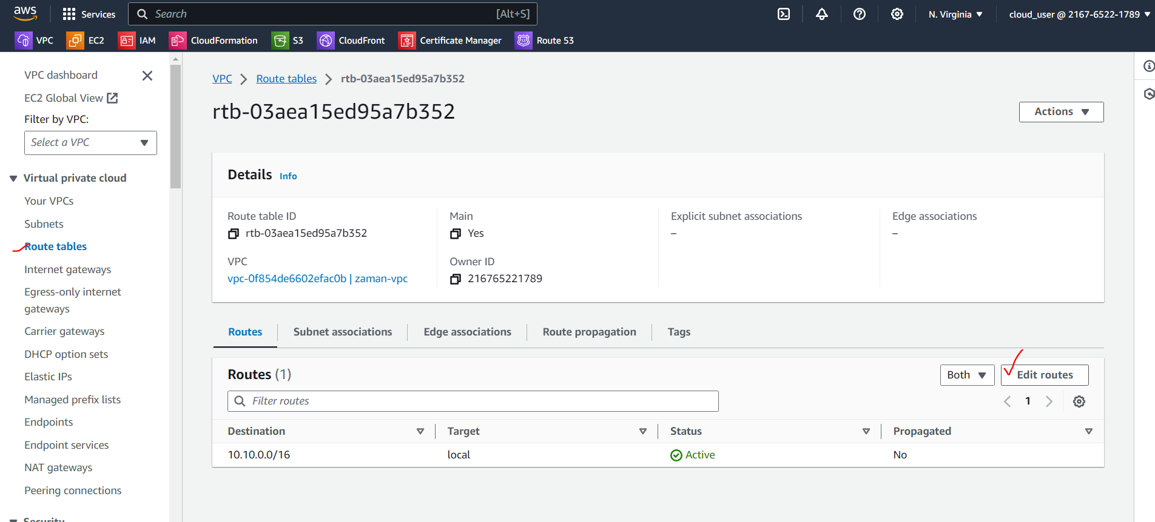

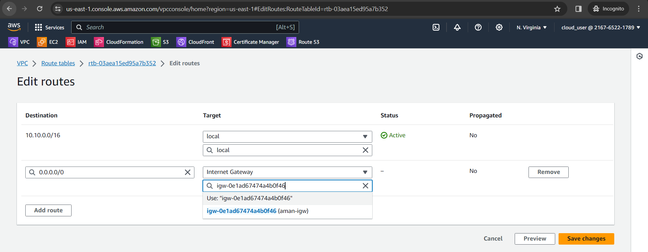

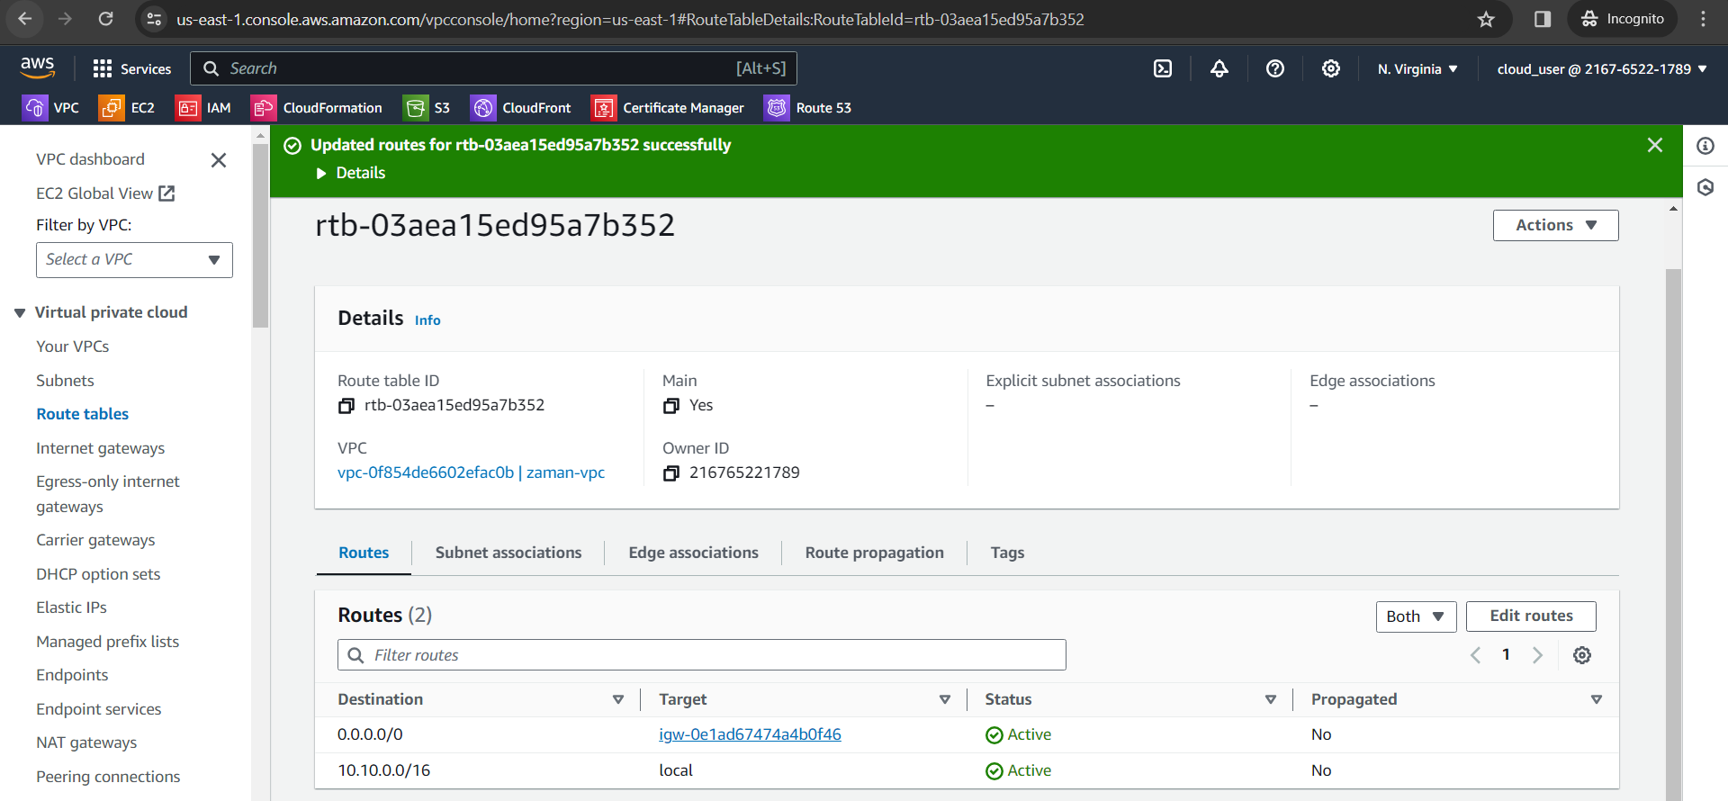

1. Create EC2 instance

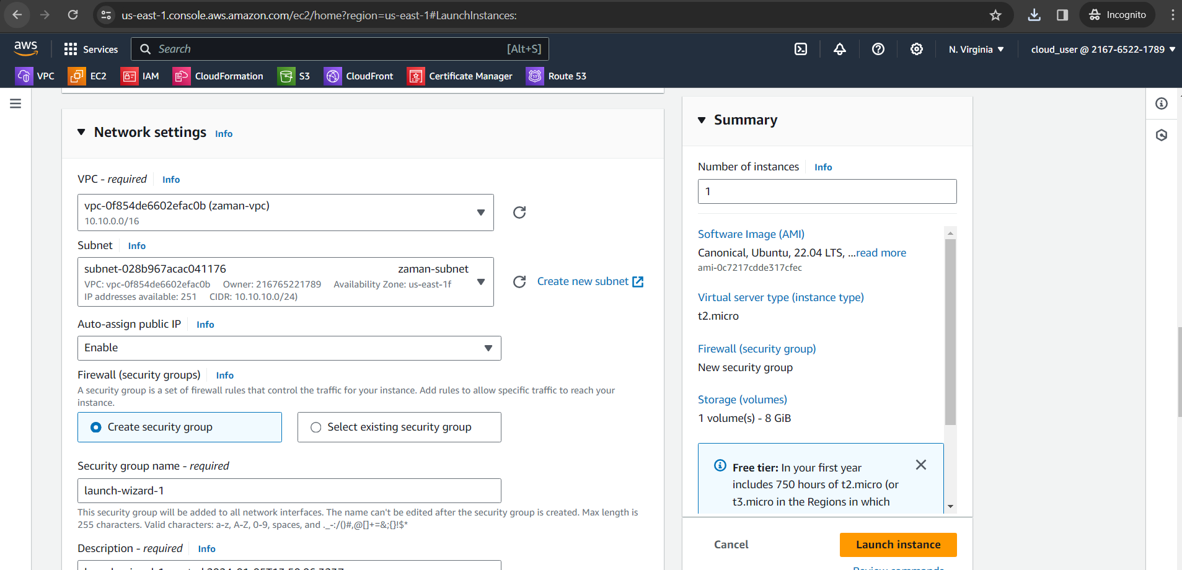

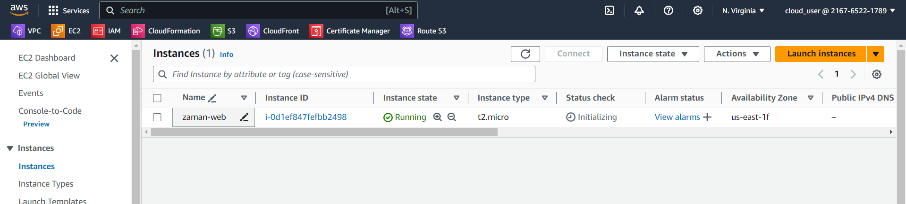

1. Installing Nginx
2. Install Nodejs
3. Create svc1 app

Sudo npm init

npm i express

node server.js

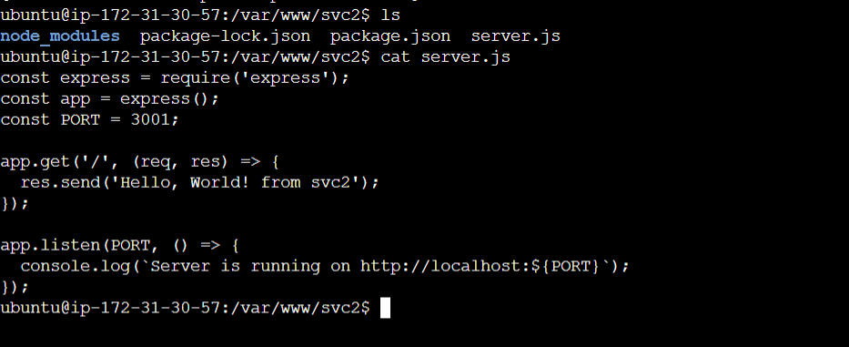

1. Configure Nginx: when request will come from api.poridhi.io and same ip, serve from svc1, and when come from fr.poridhi.io same ip, response from svc2.

nginx -t -c /etc/nginx/nginx.conf

nginx -s reload

Edit host: C:\Windows\System32\drivers\etc

